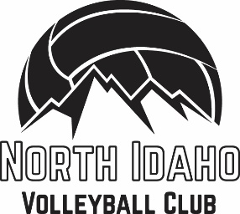
Presents our first ever BOYS team!
Q. What age group is being offered?
A. For this 2023 season we will hold tryout for u15-u18 (9th – 12th grade) boys
Q. What will the season timeline be?
A. We can be flexible on what the team and coach needs/wants. We hope for a December to February season. Practicing 2x per week and competing in 4-5 tournament days.
Q. Where will tournaments be / how much travel is expected?
A. We will strive to schedule all games no further away than Spokane, WA. Tournaments are single day format so no over night travel should be necessary.
Q. What will the cost be?
A. NIVBC is a non-profit so team fees will adjust only to what is needed to run the season: Pay coaches, gym use fees, jersey’s and tournament entry fees etc. We estimate a 12 man team should cost around $550 for the full season.
Q. Could we attend bigger tournaments outside of our area?
A. Absolutely! If the team and coaches are eager to travel to bigger tournaments NIVBC can help facilitate registrations for that. This will just add extra cost/travel.
Q. Where will practices be held?
A. Generally we book practices at Farmin elementary gymnasium or Kootenai Elementary gymnasium. Late October NIVBC will be meeting with LPOSD to schedule all gym use for the next 4 months, we will not know exact practice schedules until after that date. We will have practice schedules at tryouts for you to review
Q. How do I tryout?
A. Boys tryouts are being held Saturday Nov. 4th at SMS gym 1:00-2:30 then we will hold a quick Q &A for players/parents immediately following. PRE REGISTRATION is required: www.northidahovolleyball.com

